Write a matlab pgm to perform convolution of the following continuous s/gs

% Continuous

x1(t)=1 ; 1 <= t <= 10

x2(t)=1 ; 2 <= t <= 10

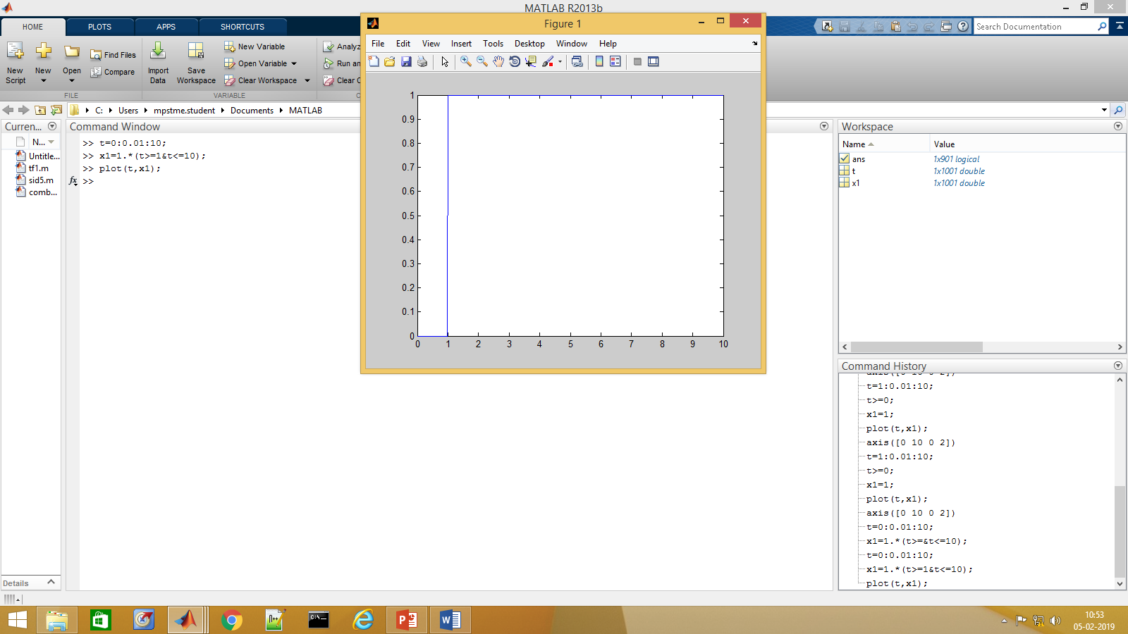

>> t=0:0.01:10;

>> x1=1.\*(t>=1&t<=10);

>> plot(t,x1);

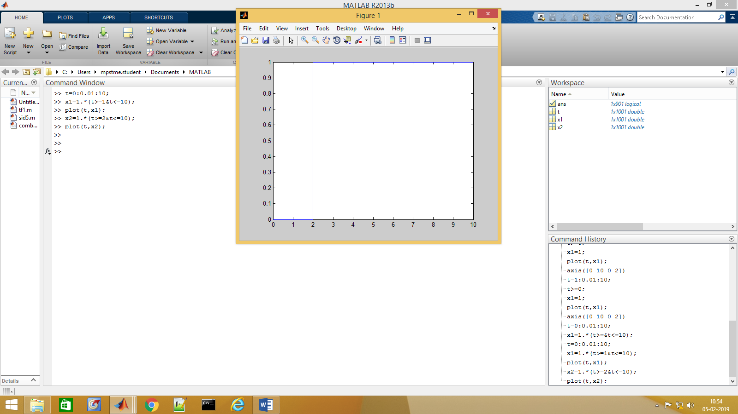

x2=1.\*(t>=2&t<=10);

plot(t,x2);

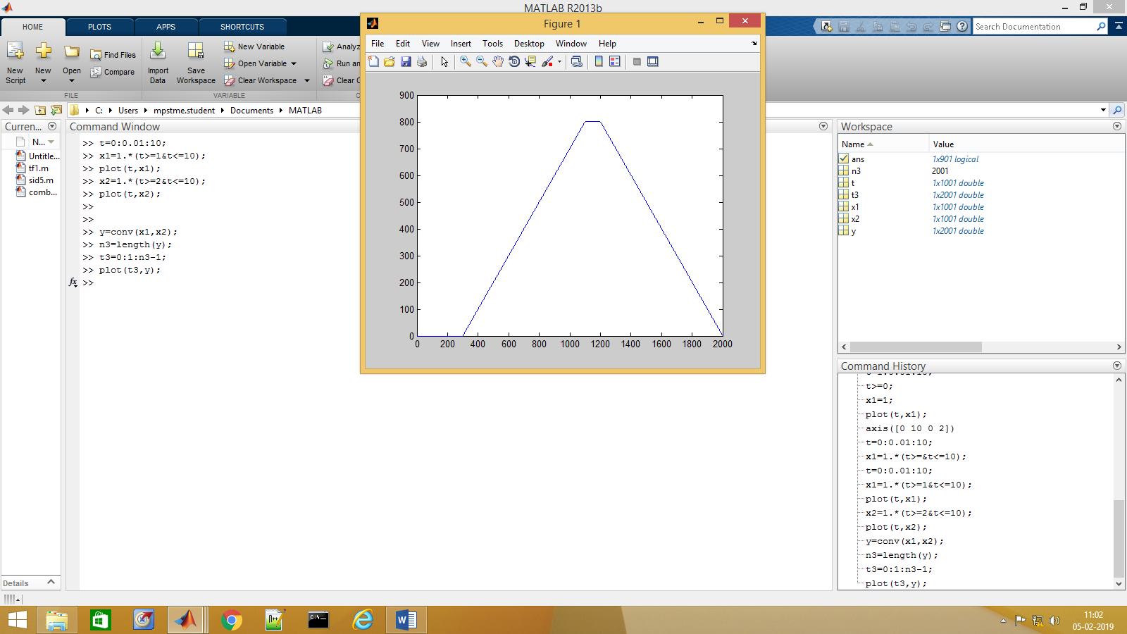

>> y=conv(x1,x2);

>> n3=length(y);

>> t3=0:1:n3-1;

>> plot(t3,y);

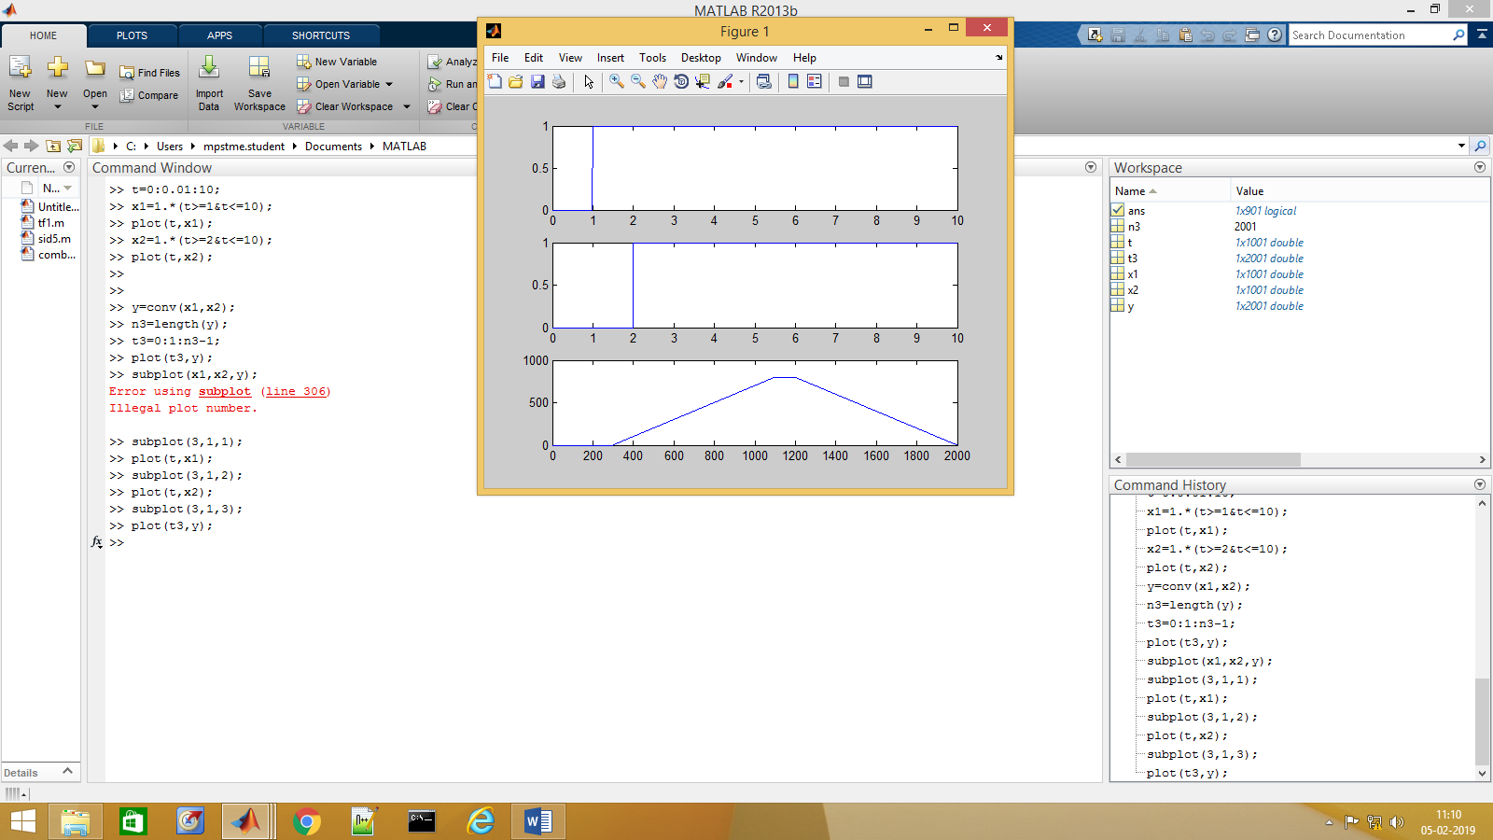

>> subplot(3,1,1);

>> plot(t,x1);

>> subplot(3,1,2);

>> plot(t,x2);

>> subplot(3,1,3);

>> plot(t3,y);